Working with Word Custom Doc Properties

Manually Adding Custom Doc Properties to a Word Template
Follow the steps below to add new doc properties to a Word template:
- Right-click the Word template (it has a .dot extension) in the Explorer, and select Open from the shortcut menu.
- Select File|Properties to open the templates’s properties sheet.
- Click the Custom tab to view the Custom page of the properties sheet. If the template already has some doc properties, they can be seen in the Properties box on this page.
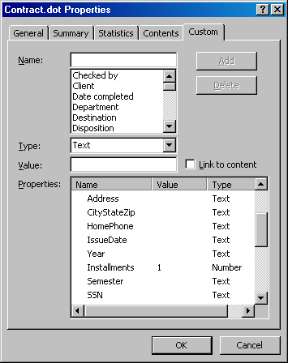
- To add a new doc property, either select a name from the list of suggested names under the Name box, or type one in.
- Select the data type for the new doc property in the Type drop-down list (Text, Date, Number, Yes or No).
- Enter a default value in the Value box. Doc properties must have a default value; for numbers it can be 0, and for Text properties it can be a space. For dates you have to enter a real date, which can be a problem (see the Notes section below for a workaround).
- Repeat as needed until you have entered all the doc properties you need, then click OK to save the new doc properties.
Now you can place DocProperty fields on the template to display the contents of the doc properties. To add a DocProperty field to the template, follow the steps below.

Word 2002
- Select Insert|Field to open the Field dialog.
- Select Document Information in the Categories box.
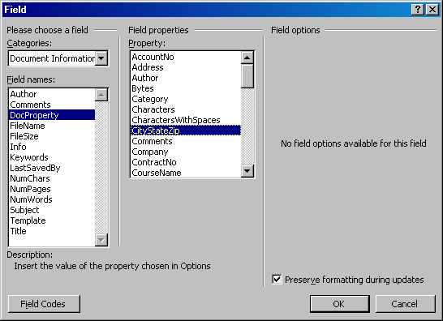
- Select DocProperty in the Field names box.
- Select the doc property you want to insert into the document, and click OK to insert the field code. (Note that there are a number of Word custom doc properties listed along with the ones you have created.)
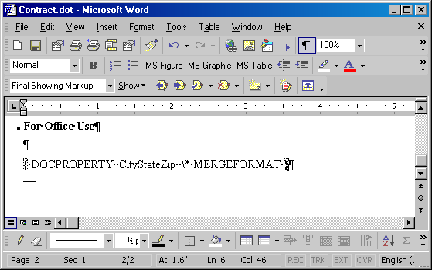

Word 2000
- Select Insert|Field to open the Field dialog.
- Select Document Information in the Categories box.
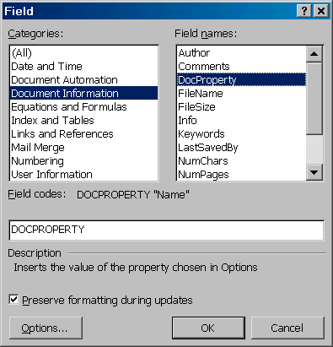
- Select DocProperty in the Field names box.
- Click the Options button to open the Field Options dialog.
- Select the doc property you want to insert in the Property box, and click the Add to Field button to add the doc property to the Field codes box.
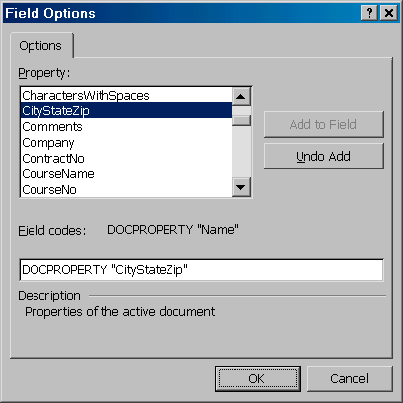
- Click OK to close the Field Options dialog, and click OK again to close the Field dialog and place the DocProperty field in the template.
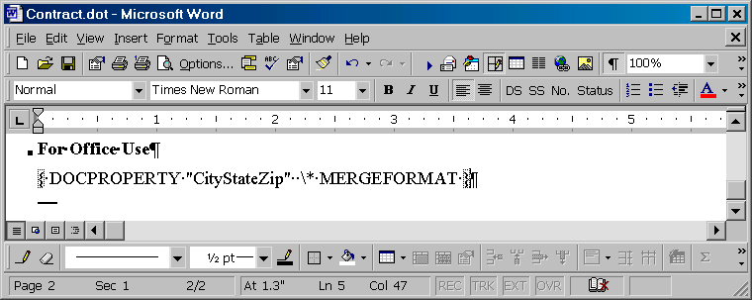

Transferring Doc Properties from One Word Document to Another with VBA Code
If you are comfortable using VBA code, you can transfer a set of doc properties from one Word document or template to another, using the following procedure. (This will save a lot of time, if you have the doc properties set up correctly in one document, and just need to copy them to another document.)
The TransferDocProps sub is a procedure that can be run from a standard module in the Word VBE window. You can paste it into the NewMacros module, or another module of your choice. The strTemplatePath line picks up the template path set as the Word User Templates path in the Word File Locations page of the Options dialog. If your documents or templates are in another location, modify this line as needed.
Set the strOriginalDoc and strTargetDoc variables to the names of the original document (or template) and the new one, to which the doc properties should be copied. When running the code, you will see the names of the doc properties listed in the Debug window as they are copied from the original document to the target document.
Sub TransferDocProps()
'Created by Helen Feddema 3-9-2002
'Last modified 3-9-2002

On Error GoTo ErrorHandler

Dim strTemplatePath As String
Dim strOriginalDoc As String
Dim strTargetDoc As String
Dim prp As Object
Dim prpsOriginal As Object
Dim prpsTarget As Object
Dim docOriginal As Word.Document
Dim docTarget As Word.Document

strTemplatePath = _
Application.Options.DefaultFilePath(wdUserTemplatesPath) & "\"
Debug.Print "Templates folder: " & strTemplatePath
strOriginalDoc = strTemplatePath & "Original.dot"
strTargetDoc = strTemplatePath & "Target.dot"
Set docOriginal = Application.Documents.Open(strOriginalDoc)
Set docTarget = Application.Documents.Open(strTargetDoc)
Set prpsOriginal = docOriginal.CustomDocumentProperties
Set prpsTarget = docTarget.CustomDocumentProperties

For Each prp In prpsOriginal
Debug.Print "Adding " & prp.Name & " to " & strTargetDoc
prpsTarget.Add Name:=prp.Name, LinkToContent:=False, _
Value:=prp.Value, Type:=msoPropertyTypeString
Next prp

ErrorHandlerExit:
Exit Sub

ErrorHandler:
MsgBox "Error No: " & Err.Number & "; Description: " & Err.Description
Resume ErrorHandlerExit

End Sub

Writing to Word Doc Properties from Access VBA Code
To write to a Word custom doc property from Access VBA code, use the following syntax.
Set prps = appWord.ActiveDocument.CustomDocumentProperties
With prps
.Item("TodayDate").Value = strDate
.Item("Name").Value = Nz(Me![txtFirstName] & " " & Me![txtLastName])
.Item("Address").Value = Nz(Me![txtAddress])
.Item("Salutation").Value = Nz(Me![txtSalutation])
.Item("CompanyName").Value = Nz(Me![txtCompanyName])
.Item("City").Value = Nz(Me![txtCity])
.Item("StateProv").Value = Nz(Me![txtStateOrProvince])
.Item("PostalCode").Value = Nz(Me![txtPostalCode])
.Item("JobTitle").Value = Nz(Me![txtTitle])
End With

For a complete procedure using this technique, see my Code Sample #2, which can be downloaded from the Code Samples page of my Web site at http://www.helenfeddema.com/CodeSamples.htm.

Notes
- Doc property names used in VBA code must match the doc property names in the Word template exactly; otherwise they won’t work.
- Don’t give your doc properties names that are already used for built-in properties or Word’s own custom doc properties (such as Company), as this will make it difficult to select the correct property from the Field dialog.
- In many cases, particularly when data is written to doc properties from VBA code, it is best to use Text doc properties for all sorts of data. If you export numeric data from Access to a Word doc property, numbers are truncated to whole values, so if you need to preserve decimal points, write the number to a Text doc property, then format it for the appropriate numeric format using field switches in Word.
- If you don’t want a default value in a Date doc property, make it a Text property instead, and use field switches to give it the appropriate Date or Time format in Word.
- If you can’t see the DocProperty field codes in your template, press Alt-F9 to view the codes (or turn them off again).

